H2
ANDERSON JUNIOR COLLEGE
HIGHER 2

CANDIDATE
NAME

PDG
INDEX NUMBER
PDG

BIOLOGY 9648/01

Paper 1 Multiple Choice 20 September 2012

1 hour 15 mins
Additional Materials: Multiple Choice Answer Paper 40 marks

READ THESE INSTRUCTIONS FIRST

Write in soft pencil.
Do not use staples, paper clips, highlighters, glue or correction fluid.
Write your name, PDG and identification number on the Answer Sheet.

There are forty questions on this paper. Answer all questions. For each question there are four possible answers A, B, C and D.
Choose the one you consider correct and record your choice in soft pencil on the separate Answer Sheet.

Each correct answer will score one mark. A mark will not be deducted for a wrong answer.
Any rough working should be done in this booklet.

Calculators may be used.

This document consists of 26 printed pages

1 | The table shows the results of tests carried out on a food from a supermarket.  What identifies the nutrients present in the food?
  Test | Result of test
  Test reagent added | Solution remained pale yellow colour
  Test reagent added and boiled | Solution remained blue colour
  Solution boiled with acid, neutralized. Test reagent added and boiled | Blue solution formed a red precipitate
  Test reagent added and shaken | Cloudy white emulsion formed
  Test reagent added | Solution changed from blue to purple
 | A | fat, non-reducing sugar, protein, starch
 | B | fat, non-reducing sugar, protein
 | C | reducing sugar, protein, starch
 | D | fat, reducing sugar, protein
2 | Which of the following are the most likely consequences for a cell lacking Structure X?  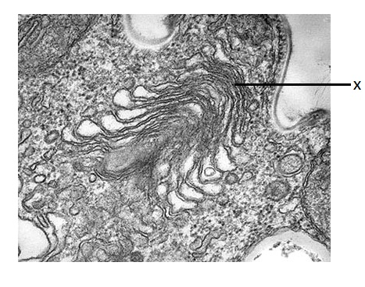  X
 | 1 | The cell dies because it is unable to make glycoproteins to detect stimuli from its environment.
 | 2 | The cell dies from a lack of enzymes to digest food taken in by endocytosis.
 | 3 | The cell dies from the accumulation of worn out organelles within itself.
 | 4 | The cell is unable to reproduce itself.
 | 5 | The cell is unable to export its enzymes or peptide hormones.
 | A | 2 and 3
 | B | 2 and 5
 | C | 3, 4 and 5
 | D | 1, 2, 3 and 5
3 | Substance X is actively transported into cells. Equal-sized samples of cells were placed in media containing different concentrations of X for an hour. The intracellular concentration of X was then measured. All other metabolic conditions were maintained at the optimum level. The graph below shows the results.  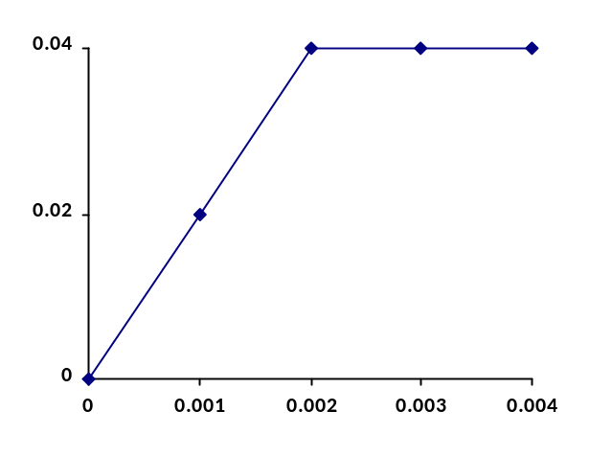  Concentration of X inside the cell  A  Concentration of X outside the cell  From the information given above, which one of the following would account for the region of the graph labeled A?
 | A | A respiratory inhibitor had been introduced.
 | B | All the active transport carriers had been operating at their maximum rate.
 | C | The active transport carriers had been inactivated by a non-competitive inhibitor.
 | D | As the internal concentration of X rose, more of the substance X was metabolised.
4 | The four acids shown below form part of an enzyme-catalyzed sequence of reactions. The addition of malonic acid results in no change in the concentration of oxoglutaric acid, an accumulation of succinic acid, and a near absence of both fumaric acid and malic acid. Further addition of fumaric acid results in the formation of malic acid. What does this information indicate about malonic acid?  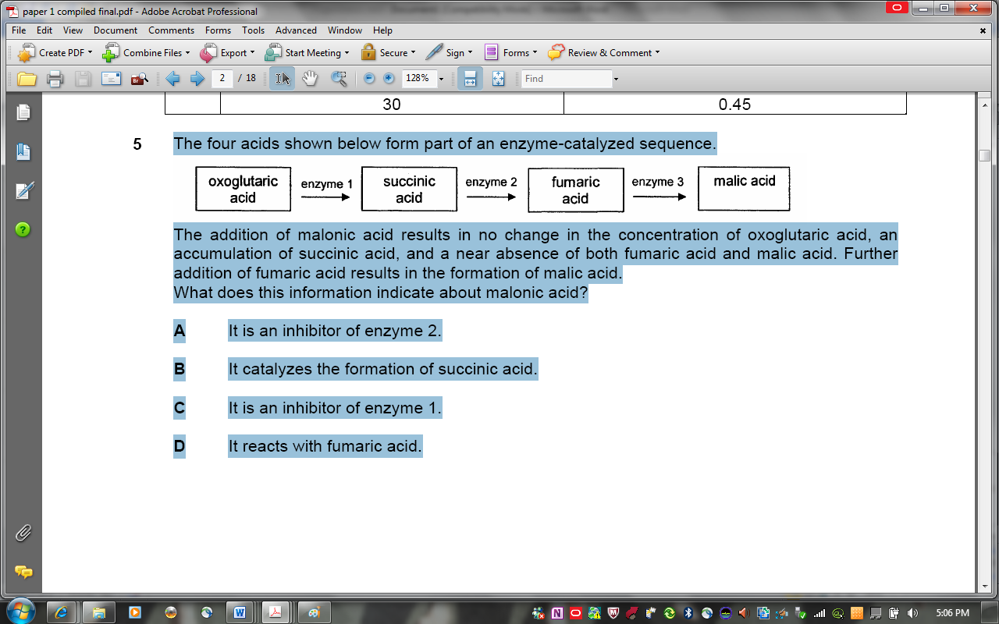
 | A | It is an inhibitor of enzyme 2.
 | B | It catalyses the formation of succinic acid.
 | C | It is an inhibitor of enzyme 1.
 | D | It reacts with fumaric acid.

5 | The graph below shows the quantity of the product formed when samples containing the same concentration of enzyme and substrate were kept at different temperature for four different duration.  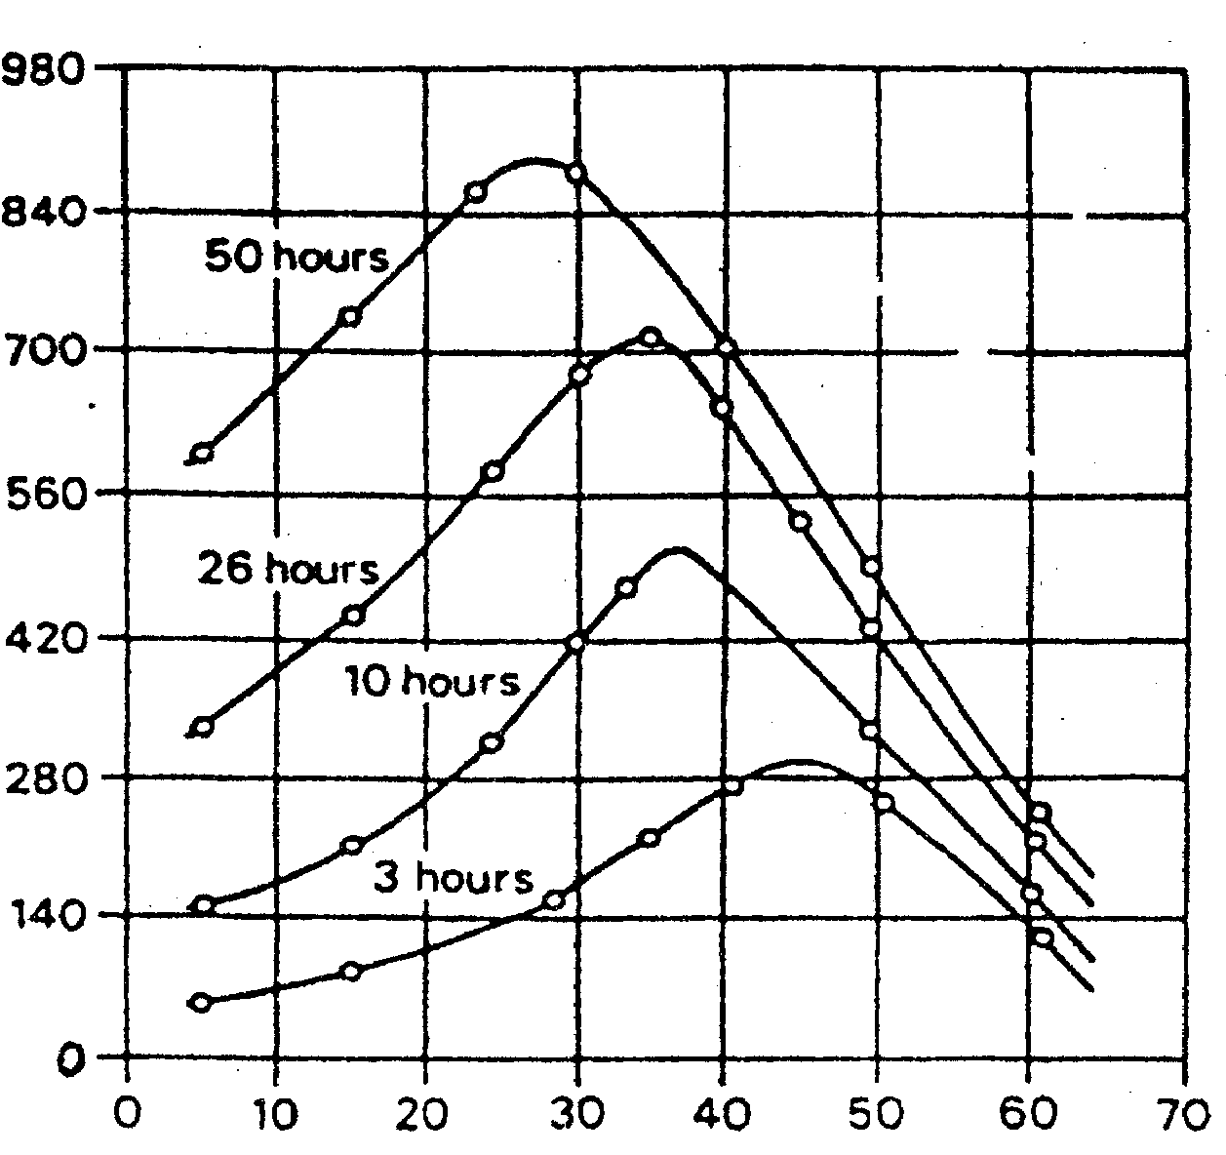  Quantity of product formed/arbitrary unit  Temperature/◦C  Which statement best explain why the optimum temperature is lowered if the duration of incubation is increased?
 | A | There is an increase in the denaturation of enzymes at high temperature.
 | B | The activation energy of the reaction is lowered at high temperature.
 | C | The product formed acts as an allosteric activator to enhance enzyme activity.
 | D | Cooperativity between subunits of the enzyme changes shape of active sites to enhance substrate binding.
6 | The graph below represents the changes in the quantity of DNA of a cell in the life cycle of an organism.  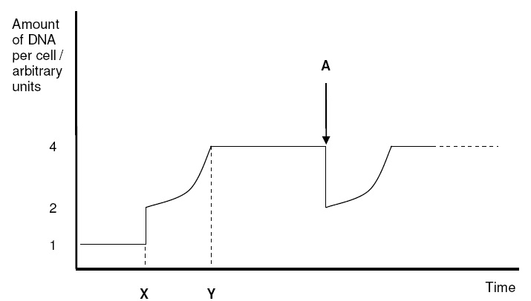  What valid conclusions can be made from the graph?
 | 1 | Interphase is the longest phase in the cell cycle.
 | 2 | Telophase occurs at A.
 | 3 | DNA replication occurs between time X and Y.
 | 4 | Fusion of gametes occurs at time X.
 | A | 3 and 4
 | B | 1 and 3
 | C | 2, 3 and 4
 | D | All the above
7 | The table shows the percentage of nitrogenous base in four samples of nucleic acids.  Which base is adenine?
  Sample | Bases
  Sample | A | B | C | D | Uracil
  1 | 19 | 31 | 30 | 19 | Nil
  2 | 27 | 23 | 24 | 26 | Nil
  3 | 25 | 25 | Nil | 25 | 25
  4 | 17 | 32 | 33 | 18 | Nil
8 | The diagrams show an investigation into semi-conservative replication of DNA.  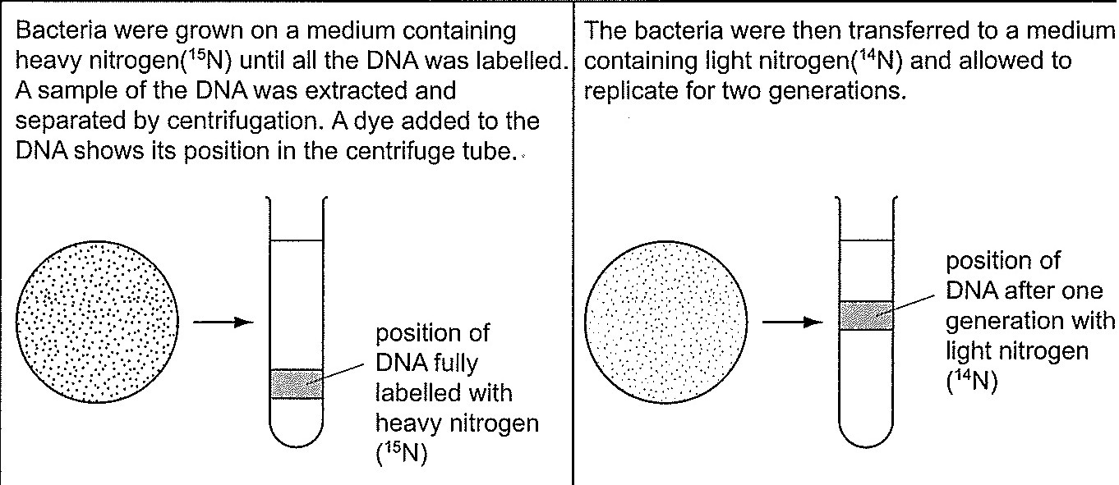  Which tube shows the position of the DNA after two generations of semi-conservative replication in light nitrogen (¹⁴N)?  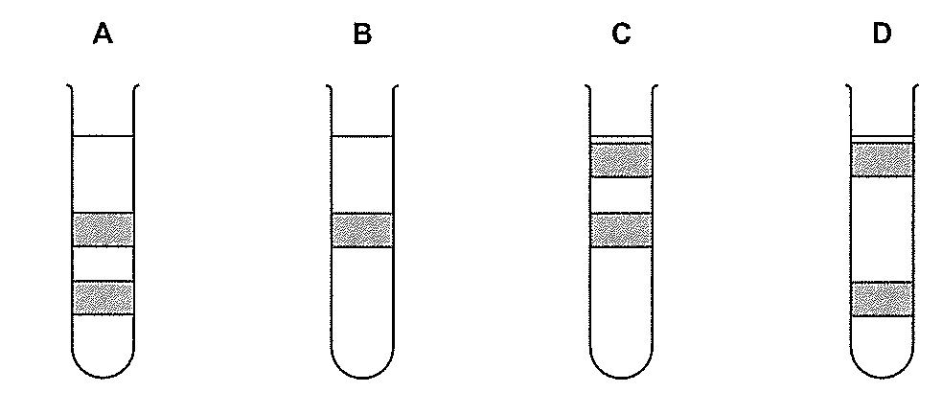

9 | The table below shows a list of characteristics displayed by mutant strains of E.coli during DNA replication and the possible reasons.  Which of the reasons correctly explain the characteristics displayed by the mutant E. coli strains?
  No | Characteristics | Enzymes or functions affected by mutation
  1 | Okazaki fragments accumulate and DNA synthesis is never completed | DNA ligase activity is missing
  2 | Supercoils are found to remain at the flanks of the replication bubbles | DNA helicase is hyperactive
  3 | Synthesis is very slow. | DNA polymerase keeps dissociating from the DNA and has to re-associate
  4 | No initiation of replication occurs. | A-T rich region at origin of replication deleted
 | A | 2 and 3
 | B | 1 and 3
 | C | 1, 3, and 4
 | D | All the above
10 | The electron micrograph shows 5 structural components P, Q, R, S and T involved in the expression of a particular gene in a prokaryotic cell.  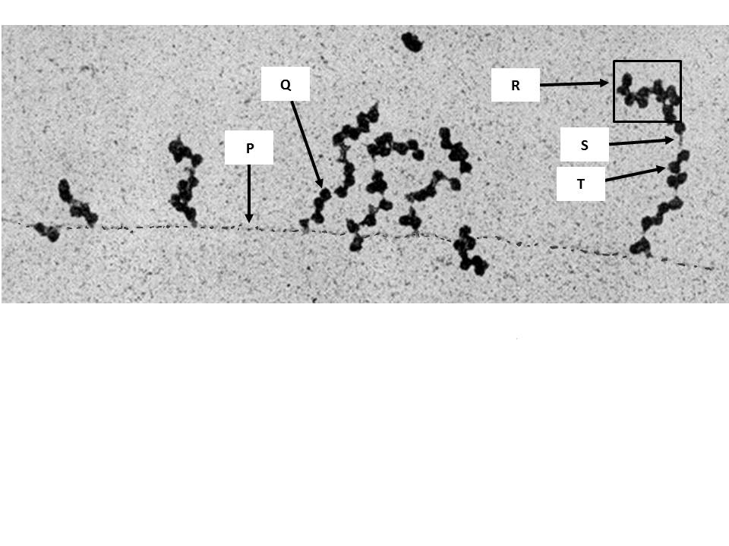  Which of the following statement(s) is / are true?
 | 1 | RNA polymerase adds incoming nucleotides to form P.
 | 2 | The products synthesized by Q and T are identical.
 | 3 | Structure R can also be found in eukaryotes.
 | 4 | T is involved in forming S.
 | A | 3 only
 | B | 2 and 3 only
 | C | 1, 2 and 4 only
 | D | All of the above
11 | The active form of the enzyme tryptophan synthetase of the bacterium E.coli has the amino acid glycine (gly) at X. In some cultures of E.coli, gly at X is replaced by an arginine (arg) and the enzyme is inactive.  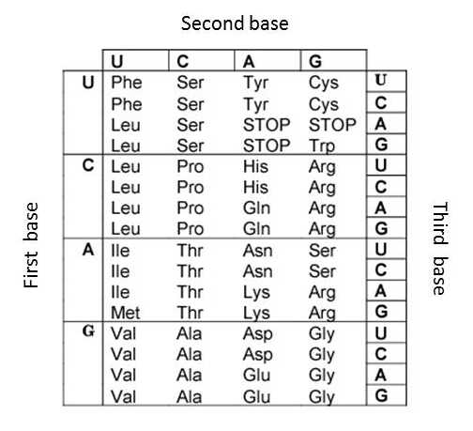  What would be the anticodon of the tRNA bringing the amino acid for the inactive form of the enzyme at X?
 | A | CGC
 | B | UCU
 | C | GGU
 | D | CCC
12 | Two strains of the bacterium Streptococcus pneumoniae were used in an experiment on mice. The smooth (S) strain is a virulent strain whereas the rough (R) strain is a non-virulent strain. The diagram below shows the results of the experiment.  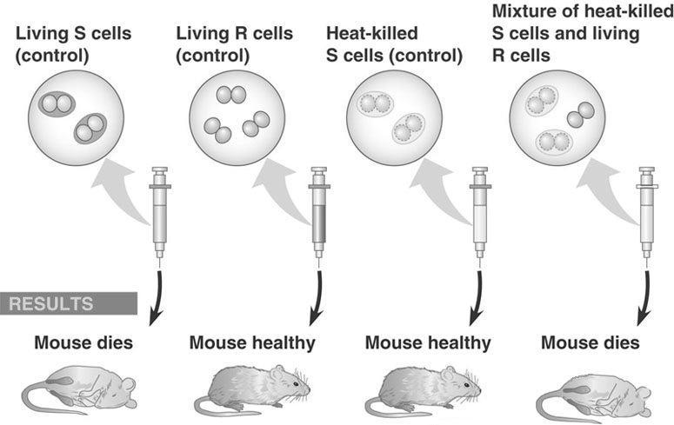  Which of the following accounts for the death of the mouse introduced with a mixture of heat-killed S cells and living R cells?
 | A | Binary fission
 | B | Conjugation
 | C | Transduction
 | D | Transformation
13 | In E. coli, the production of enzymes for tryptophan synthesis is carefully controlled according to the organism’s metabolic needs. A mutation in the gene encoding the tryptophan repressor has occurred, such that the repressor can bind DNA without the co-repressor. What effect on enzyme production can be expected under this condition?
 | A | High-level enzyme production under any condition.
 | B | High-level enzyme production in the absence of tryptophan, no activity in the presence of tryptophan.
 | C | No enzyme production in the absence of tryptophan, high-level activity in the presence of tryptophan.
 | D | No enzyme production under any conditions.
14 | IPTG is an analogue of lactose that binds to lac repressor in the same fashion as allolactose. However, it cannot be metabolized by β-galactosidase. E. coli cells, which were grown in the absence of lactose and glucose, were initially supplemented with IPTG. After 10 minutes, glucose was added to the cells. 10 min after glucose was added, cAMP was added to the cells.  Which of the following graphs best represent how the concentration of lac operon mRNA varied during the experiment?  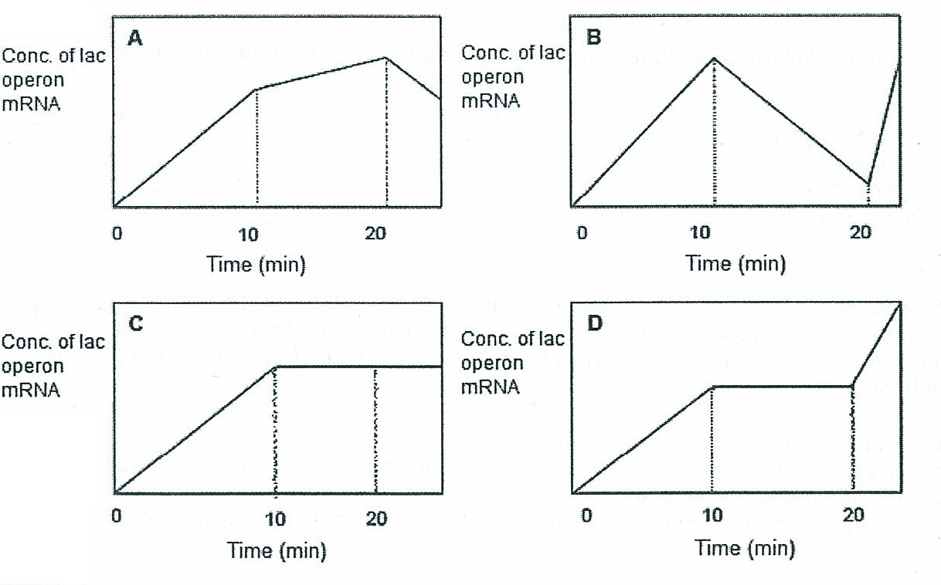
15 | Two new viruses E and Z, which infect eukaryotic cells, have been identified.  In one experiment, the nucleic acid from each virus is isolated and analyzed over a range of temperatures. The light absorbance of nucleic acids changes when denaturation or annealing occurs. The behaviour of the nucleic acid from each virus is shown in the graph.  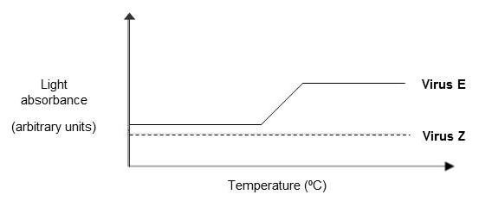  In a second experiment, it is found that treatment with reverse transcriptase inhibitors or with inhibitors of DNA synthesis blocks the ability of Virus Z to infect cells. In contrast, reverse transcriptase inhibitors have no effect on the ability of virus E to infect cells but DNA synthesis inhibitors block infection by Virus E.  Which of the following conclusions can be drawn from both the experiments?
 | A | The genome of Virus E is single-stranded RNA and that of Virus Z is double-stranded DNA.
 | B | The genome of Virus E is double-stranded DNA and that of Virus Z is single-stranded RNA.
 | C | The genome of Virus E is double-stranded RNA and that of Virus Z is single-stranded DNA.
 | D | The genome of Virus E is double-stranded DNA and that of Virus Z is double-stranded RNA.
16 | Which of the following shows the possible effects of a single nucleotide substitution in each of the following locations in a gene on the production of the protein product of that gene?
 |  | Promoter | Start codon |  |  | Stop codon |  |  | Middle of an intron
 | A | No protein product is produced | Protein product is longer than normal |  |  | Protein product is normal |  |  | Too much protein product is produced
 | B | Too much protein product is produced | No protein product is produced |  |  | Protein product is longer than normal |  |  | Protein product is normal
 | C | Protein product is normal | Protein product is shorter than normal |  |  | Too much protein product is produce |  |  | Protein product is longer than normal
 | D | Protein product is longer than normal | Protein product is normal |  |  | Protein product is shorter than normal |  |  | No protein product is produced
17 | 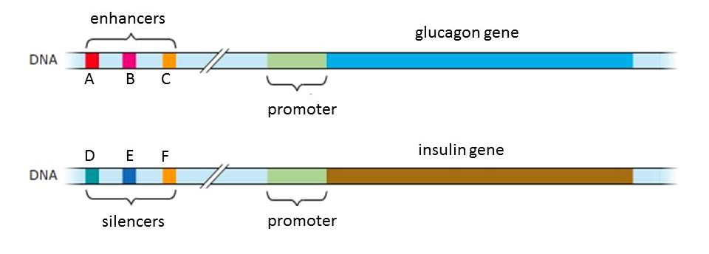  The diagram below shows the control elements and two genes found in the human genome.  Which of the following statement(s) about the above genes is /are true?
 | 1 | The glucagon gene is found only in the α-cells of the Islets of Langerhans while the insulin gene is found only in the β-cells of the Islets of Langerhans.
 | 2 | Binding of control elements, specific transcription factors and RNA polymerase at the promoter initiates transcription of glucagon.
 | 3 | The glucagon gene will be transcribed at a high level when transcription factors bind to control elements A, B, and C
 | 4 | The expression of insulin can only be suppressed when transcription factors bind to control elements D, E and F.
 | A | 3 only
 | B | 2 and 3 only
 | C | 2, 3 and 4 only
 | D | 1, 2 and 4 only
18 | Which pair of statements correctly describes centromeres and telomeres?
 |  | Centromeres |  |  |  | Telomeres
 | A | Only present when DNA condense to become sister chromatids |  |  |  | Only present when chromosome unwinds during interphase
 | B | A change in the centromeric sequence may result in aneuploidy |  |  |  | A change in the telomeric sequence may result in chromosomal mutation
 | C | Is split during cell nuclear division |  |  |  | Is shortened during interphase
 | D | Always found in the middle of a chromosome |  |  |  | Always found at the ends of a chromosome
19 | In mice, the gene loci for mice coat pattern and whisker curvature are located on different chromosomes. For the gene locus controlling coat pattern, the allele for ‘dappled’ coat (D) is dominant to the allele for ‘plain’ coat (d). For the gene locus controlling whisker curvature, the allele for ‘straight’ whiskers (W) is dominant to the allele for ‘bent’ whiskers (w).  A male mouse with plain coat and bent whiskers was mated to a female dappled mouse with straight whiskers. The phenotypes and number of offspring mice having each phenotype was counted and recorded in the table below.  In a separate cross, a female mouse with plain coat and bent whiskers was mated to a male dappled mouse with straight whiskers. The phenotypes and number of offspring mice having each phenotype was counted and recorded in the table below.  If the female parental mice from the first cross was mated to the male parental mice from the second cross and 96 offspring was produced, how many offspring mice would be expected to have dappled coat and straight whiskers?
  Phenotype | Number of offspring
  dappled, straight whiskers female | 52
  dappled, straight whiskers male | 39
  plain, straight whiskers female | 44
  plain, straight whiskers male | 48
  Phenotype | Number of offspring
  dappled, straight whiskers female | 24
  plain, straight whiskers male | 31
 | A | 24
 | B | 72
 | C | 96
 | D | None
20 | Huntington’s disease is a genetic disorder that results in the degeneration of the nervous system.  Several discoveries were made regarding Huntington’s disease.  - The male offspring of an affected female and an unaffected male also has Huntington’s disease.  - The male offspring of an affected male and an unaffected female has 50% chance of getting the disease.  - In affected individuals, level of a protein necessary for brain cell development is approximately halved.  - The mutant allele codes for a non-functional protein as its DNA sequence contains tandem repeats of a particular codon sequence.  - Typically, symptoms do not start until after the age of 30 and the disease progressively worsens with age.  - People affected by the disease die during the age of 40 to 50.  What do these discoveries suggest about Huntington’s disease?
 | A | The allele resulting in Huntington’s disease is located on the X chromosome.
 | B | Normal brain cell development requires expression of two normal alleles to produce normal levels of the critical protein and thus the disease-causing allele is dominant.
 | C | It is controlled by multiple genes and symptoms can be influenced by environmental factors.
 | D | The disease-causing allele is recessive to the normal allele.
21 | Fruit shape in summer squash plants is controlled by two independently segregating gene loci.  The alleles for each gene locus and the traits they code for are shown below.  When a plant has at least one copy of the dominant allele of both genes, the fruits of the plant will be disk-shaped instead.  Plants which have spherical fruits are selfed and the numbers of offspring plants having different fruit shapes were recorded.  Which of the following statements are true?  - The mode of inheritance for fruit shape in summer squash is recessive epistasis.  - Summer squash plants which are pure-breeding for fruit shape will always have either long fruits or disk-shaped fruits.  - When two heterozygotes are crossed, the phenotypic ratio will be 9 disk-shaped fruit: 6 spherical fruit : 1 long fruit.  - The proteins coded for by the gene loci, A/a and B/d are involved in the same biochemical pathway that controls fruit shape development in summer squash.
  A | spherical | a | long
  B | spherical | b | long
  Disk-shaped | 354
  Spherical | 248
  Long | 38
 | A | 1 and 2
 | B | 1 and 4
 | C | 2 and 3
 | D | 3 and 4
22 | The family tree below shows the inheritance of hypercholesterolaemia in three generations of a family. Children who inherited the dominant mutant allele from both parents rarely survive beyond puberty.  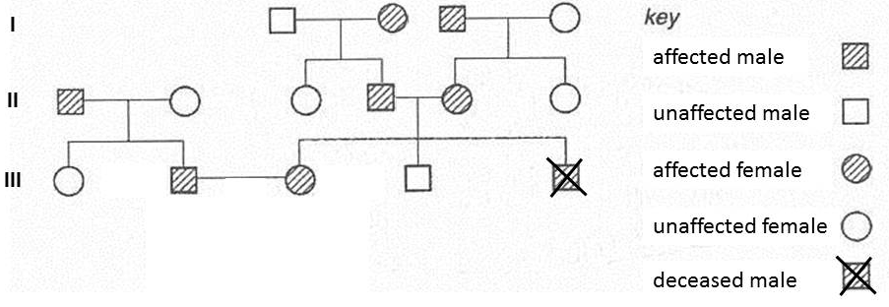  What is the frequency of the dominant allele in the third generation?
 | A | 0.25
 | B | 0.40
 | C | 0.50
 | D | 0.67
23 | Two separate experiments were conducted to investigate the production of oxygen in photosynthesizing plants.  In experiment 1, an illuminated suspension of photosynthesizing algae Chlorella was given carbon dioxide containing a heavy isotope of oxygen, ¹⁸O. The amount of radioactively labeled oxygen (¹⁸O₂) produced from the Chlorella suspension was then measured.  The experiment was then repeated but with Chlorella suspension given water molecules containing ¹⁸O (experiment 2).  The results are shown in the table below.  Which of the following conclusions can be inferred from the above experimental results?
  Time after introducing ¹⁸O / min | Amount of ¹⁸O₂ produced / arbitrary units
  Time after introducing ¹⁸O / min | Experiment 1 (with C¹⁸O₂) | Experiment 2 (with H₂¹⁸O)
  0 | 0 | 0
  5 | 0 | 0.05
  10 | 0 | 0.24
  15 | 0 | 0.44
  20 | 0 | 0.77
 | A | Oxygen atoms in the carbon dioxide molecule is incorporated into Calvin cycle metabolites and subsequently sucrose molecules produced from photosynthesis.
 | B | Water is the source of oxygen evolved during photosynthesis.
 | C | Oxygen is the final electron acceptor of the non-cyclic photophosphorylation.
 | D | The rate of photosynthesis increases with time.
24 | The pathway by which carbon dioxide is converted to organic compounds during photosynthesis was investigated using the apparatus shown in the figure below.  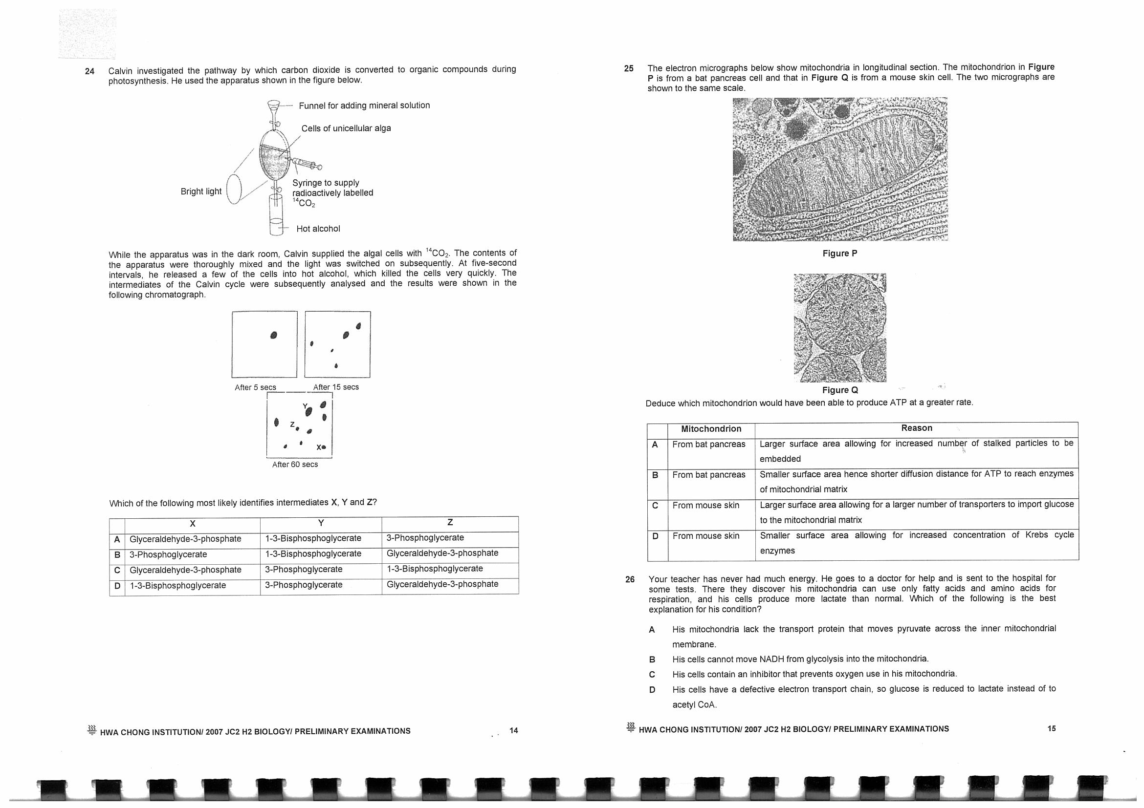  The algal cells are supplied with ¹⁴CO₂ while the apparatus was placed in the dark room. Subsequently, the contents of the apparatus were thoroughly mixed and the light was switched on. A few cells were released into hot alcohol at five-minute intervals and the cells were killed very quickly. Intermediates of the Calvin cycle were subsequently analysed by chromatographic techniques. Any radioactive compounds present showed up on X-ray films as darkened areas.  Which of the following most likely identifies intermediates X, Y and Z?
   | X | Y | Z
  A | Glyceraldehyde-3-phosphate | 1,3-Bisphosphoglycerate | Glycerate-3-Phosphate
  B | Glycerate-3- Phosphate | 1,3-Bisphosphoglycerate | Glyceraldehyde-3-phosphate
  C | Glyceraldehyde-3-phosphate | Glycerate-3-Phosphate | 1,3-Bisphosphoglycerate
  D | 1,3-Bisphosphoglycerate | Glycerate-3-Phosphate | Glyceraldehyde-3-phosphate
25 | When sodium iodoacetate is added to healthy liver cells in aerobic conditions, glucose is broken down but no pyruvate is formed.  The activity of which respiratory enzyme may be affected by this inhibitor?
 | A | pyruvate dehydrogenase
 | B | citrate synthase
 | C | cytochrome C oxidase
 | D | glyceraldehyde-3-phosphate dehydrogenase
26 | Which of the following statements is true about anaerobic respiration?
 | A | Fatty acids can be broken down to release energy for ATP synthesis during anaerobic respiration.
 | B | During anaerobic respiration, NAD is regenerated to ensure that dehydrogenation of Krebs’ cycle intermediates can continue.
 | C | During anaerobic respiration, ATP is only generated via substrate level phosphorylation.
 | D | Anaerobic respiration only occurs in bacteria and yeast cells as they lack mitochondria.
27 | The diagram shows the sequence of events occurring as a nerve impulse is transmitted across the synapse.  The numbered arrows represent the events that occur.  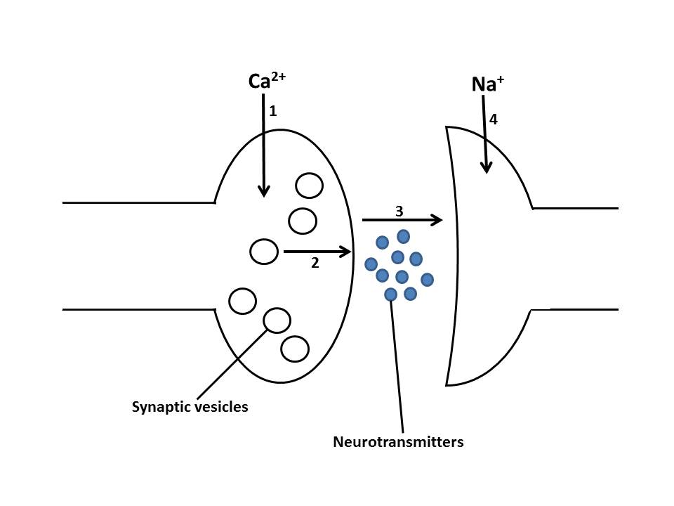  Colchicine is an alkaloid drug that inhibits microtubule formation.  Which event(s) will be disrupted when neurones are treated with Colchicine?
 | A | 1 only
 | B | 2 and 3
 | C | 2, 3 and 4
 | D | 1, 2, 3 and 4
28 | The diagram below shows a normal action potential.  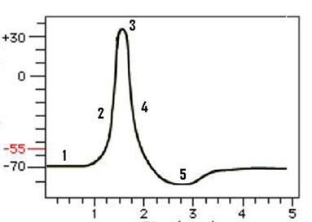  Membrane potential (mV)  Time (msec)  Which of the following statements are true?
 | I | At stage 1, the potential is a result of the selective permeability of the membrane as well as active transport of ions.
 | II | At stage 2, the permeability of the membrane to sodium is increased due to the opening of the ungated sodium channels.
 | III | Stage 4 ensures that the nerve impulse travels in one direction along the axon.
 | IV | Stage 5 ensures that the nerve impulse travels in one direction along the synapse.
 | A | I and III
 | B | II and III
 | C | III and IV
 | D | II, III and IV
29 | The flow chart below shows the different stages of blood osmoregulation by antidiuretic hormone (ADH).  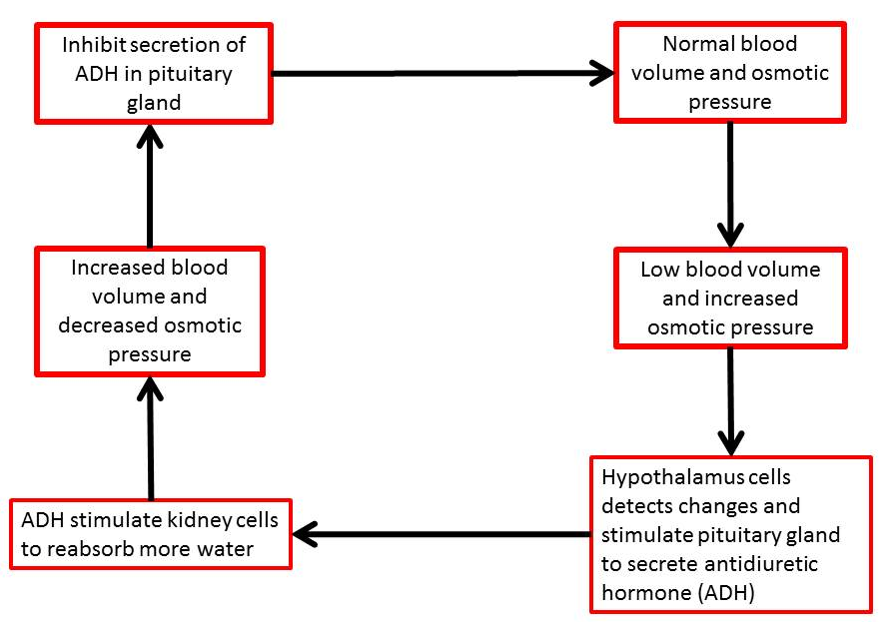  Which of the following statements are true?
 | 1 | The hypothalamus and pituitary gland cells are the effector cells.
 | 2 | Negative feedback occurs when the increase in blood volume and decrease in osmotic pressure is detected by pituitary gland cells
 | 3 | The flow chart shows that corrective mechanism is triggered by increasing blood volume and decreased osmotic pressure
 | 4 | Blood volume and osmotic pressure is regulated by endocrine control
 | A | 1 and 2
 | B | 2 and 4
 | C | 1 and 4
 | D | 2, 3 and 4
30 | In order to study the IP₃/DAG signaling pathway, biochemical studies were carried out to measure levels of specific cellular components in liver cells.  Liver cells were treated with a ligand known to activate the IP3/DAG pathway. At regular thirty-second intervals, some cells were lysed to obtain cell extracts and the levels of Phosphatidylinositol 4,5-bisphosphate (PIP₂), Inositol 1,4,5-trisphosphate (IP₃), Ca²⁺ and Protein kinase C (PKC) were measured.  The results were shown in the table below.  Based on the results, which of the following is the correct sequence of cellular components in the cell signaling pathway?
  Time / s | Levels of Cellular Component / arbitrary units
  Time / s | PIP₂ | PKC | IP₃ | Ca²⁺
  30 | 5.3 | 0.0 | 0.0 | 1.2
  60 | 4.8 | 0.0 | 0.7 | 1.2
  90 | 2.9 | 0.0 | 2.8 | 1.2
  120 | 1.8 | 0.0 | 3.6 | 4.7
  150 | 1.8 | 9.0 | 4.6 | 8.0
 | A | PKC → IP₃ → Ca²⁺ → PIP₂
 | B | IP₃ → PKC → Ca²⁺ → PIP₂
 | C | PIP₂ → IP₃ → Ca²⁺ → PKC
 | D | Ca²⁺ → PIP₂ → IP₃ → PKC
31 | The different forms of natural selection can be distinguished according to their effect on the body size of the pink salmon (Onchorhynchus gorbuscha).  Select the correct form of natural selection for each of the following sets of graphs.  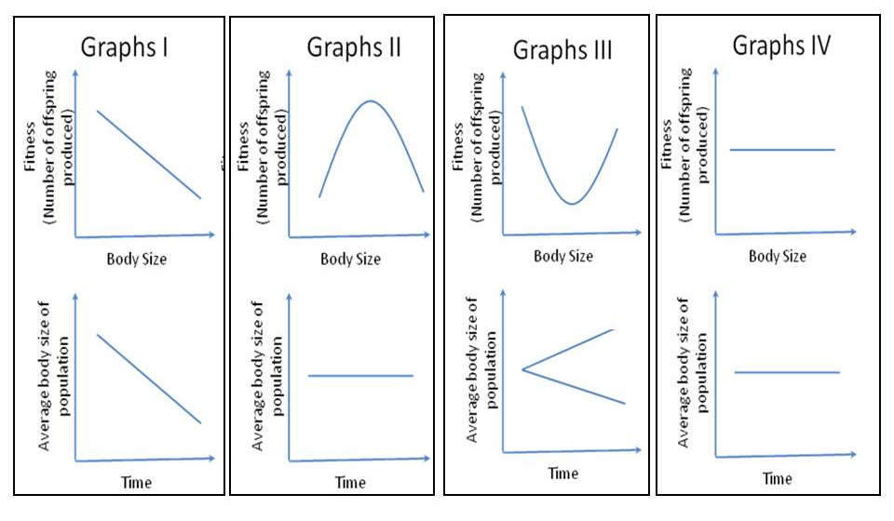  Fitness  (No of offspring produced)  Fitness  (No of offspring produced)  Fitness  (No of offspring produced)  Fitness  (No of offspring produced)  Average body size of population  Average body size of population  Average body size of population  Average body size of population
 |  | Graphs I | Graphs II |  |  | Graphs III |  |  | Graphs IV
 | A | Disruptive selection | Directional selection |  |  | Stabilizing selection |  |  | No selection
 | B | No selection | Stabilizing selection |  |  | Directional selection |  |  | Disruptive selection
 | C | Directional selection | Stabilizing selection |  |  | Disruptive selection |  |  | No selection
 | D | Directional selection | Disruptive selection |  |  | No selection |  |  | Stabilizing selection
32 | The graph below shows the distribution of huntsman spiders at a forest boundary:  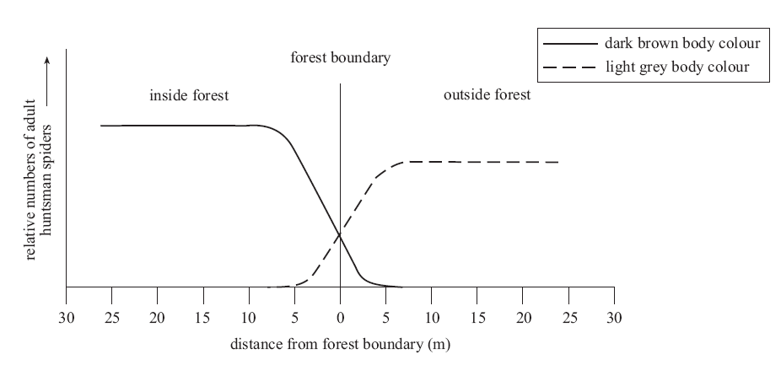  One species of huntsman spider (Isopeda isopedella) varies in body colour from dark brown to light grey. In one community at the forest boundary, two populations of this species were found. Some were found living inside the forest and others were found living just outside the forest. The relative numbers of dark brown adult spiders and light grey adult spiders found at certain distances from the forest boundary are shown in the graph above.  Which of the following can be least inferred from the graph?
 | A | The type of selective advantage inside the forest is different from the type of selective advantage outside the forest.
 | B | The plateau in the population number as seen inside the forest and outside the forest is due to competition among the adult spiders for limited resources.
 | C | The lower plateau of spider population outside the forest compared to that of inside the forest is due to the presence of additional selection pressure existing outside the forest.
 | D | Dark brown huntsman spiders are not eaten by birds inside the forest as their colour allows them to camouflage and hence provides a selective advantage.
33 | Which statement(s) related to the molecular clock is/are not true?
 | 1 | The molecular clock involves comparing mutations that occur only in non-coding DNA regions.
 | 2 | A mutation that returns a mutated nucleotide back to its original state can cause an underestimation of the time that elapsed since two related species diverged from a common species.
 | 3 | The molecular clock is based on the constant rate of occurrence of mutations.
 | 4 | Genes that are essential to survival have lower clock rate.
 | A | 2 only
 | B | 1, 2 and 3 only
 | C | 1 and 3 only
 | D | All of the above
34 | A species of seagulls exists as a large number of different populations on separate islands of the Azores archipelago. Each population contains 100 individuals.  In the original populations, the black-coloured seagull is due to a dominant allele while white-coloured individuals are due to recessive allele. In each population, 81% individuals are white-coloured.  During a storm, two males and two females were blown 300 miles to the West, to an isolated island, known as Survivor Island, uninhabited by seagulls. They reproduced and founded a new population. They could not disperse back to the original habitat, nor can any new seagulls cross to the new island. By chance, all four original colonists were white-coloured seagulls.  Over the course of the next 2000 years, these Survivor Island seagulls evolved mating displays that differ from those of the parent population. When the original Azores archipelago seagulls were introduced to Survivior island, the two kinds of seagulls do not interbreed.  Which of the following options is correct regarding the paragraphs above?
 |  | Mechanism that alters allele frequency of the isolated population on Survivor Island |  | Frequency of the recessive allele on Survivor Island right after the storm |  |  | Type of mechanism that keeps the two species of seagulls from interbreeding
 | A | Genetic drift |  | 0.81 |  |  | Behavioural Isolation
 | B | Gene flow |  | 100 |  |  | Mechanical Isolation
 | C | Genetic drift |  | 1.00 |  |  | Behavioural Isolation
 | D | Gene flow |  | 81 |  |  | Mechanical Isolation
35 | Because eukaryotic genes contain introns, they cannot be properly translated by bacteria. Which methods listed below can be used to avoid the problems associated with introns.
 | 1 | Alter the bacteria so that they can splice RNA.
 | 2 | Synthesise a length of DNA carrying the correct coding sequence by adding nucleotides one by one based on the amino acid sequence.
 | 3 | Synthesise a complementary sequence of DNA from mRNA.
 | 4 | Insert the gene into a yeast artificial chromosome and using a yeast cell as the host cell.
 | A | 1 only
 | B | 3 and 4
 | C | 2, 3 and 4
 | D | All the above
36 | In an investigation of a gene suspected to be involved in a genetic disease, separate PCR procedures were done using genomic DNA and RNA isolated from healthy, wild type (WT) and diseased cells (mutant). The PCR products were analysed on agar gels. The sizes of the bands in the molecular weight marker (M) are indicated in base-pairs.  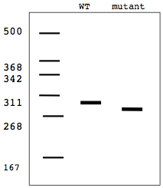  Genomic DNA  RNA  M  M  600  468  442  411  368  267  600  468  442  411  368  267  WT mutant  WT mutant  Which of the following best explains the results obtained?
 | A | Deletion of an exon in the mutant.
 | B | Deletion of a splice site in the mutant.
 | C | Deletion of several codons in the mutant.
 | D | Deletion of several introns in the mutant
37 | What is the key reason for using a greater range of probes and restriction enzymes in DNA fingerprinting?
 | A | It increases the likelihood that one of the probes will bind to the polymorphic region of the DNA after the latter is cut by the restriction enzymes.
 | B | It is necessary for the creation of unique DNA fingerprints from two individuals’ DNA that are significantly different in sequence.
 | C | It permits more regions of the DNA to be analysed so as to reduce the possibility that two individuals’ DNA would produce the same banding pattern.
 | D | It allows all the DNA bands produced via restriction enzymes cutting to be detected so as to give a more accurate DNA fingerprint.
38 | In the future, therapeutic cloning may produce new tissues and organs for people who are seriously ill. The figure below show stages in producing new tissues and organs by therapeutic cloning.  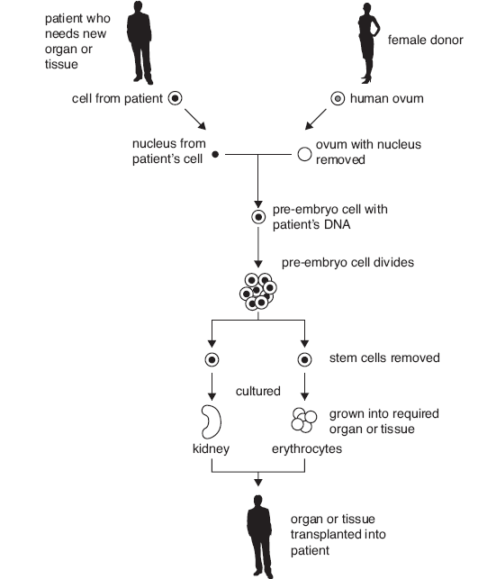
 | Which of the following statement about therapeutic cloning is correct?
 | A | The above procedure can be modified to treat ADA-SCID but not sickle cell anemia.
 | B | The ovum containing the patient’s DNA is a diploid cell.
 | C | The pre-embryo cells are multipotent cells because they contain an adult patient’s DNA.
 | D | Therapeutic cloning in this manner is more ethical than using stem cells directly from a donor
39 | The diagram below shows steps of the procedure that can be used to produce plantlets from protoplast cells isolated from leaves.  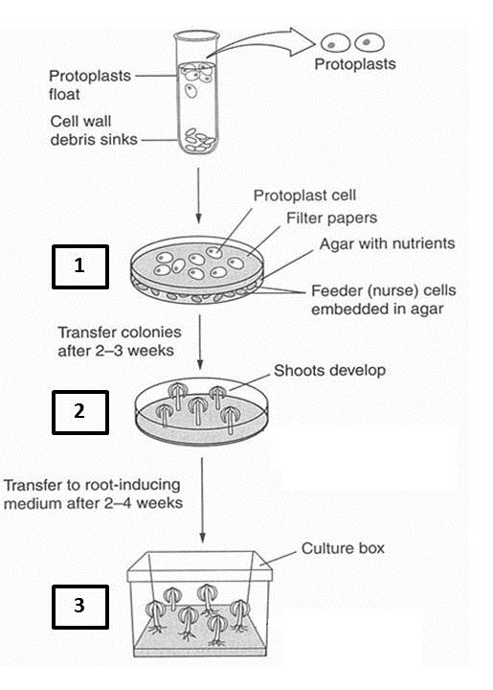  Which of the following auxin:cytokinin ratios are correctly employed in growth medium for the respective stages of plant tissue culture?
 |  | 1 |  |  | 2 |  |  | 3
 | A | 2: 0.5 |  |  | 2: 0.2 |  |  | 2: 0.02
 | B | 2: 0.2 |  |  | 2: 0.02 |  |  | 2: 0.5
 | C | 2: 0.02 |  |  | 2: 0.2 |  |  | 2: 0.5
 | D | 2: 0.2 |  |  | 2: 0.5 |  |  | 2: 0.02
40 | A gene coding for a growth hormone is spliced together with an active promoter and introduced into Atlantic Salmon using genetic modification.  Which of the following facts about genetically modified (GM) Atlantic Salmon is not likely to be of concern?
 | A | The GM salmon is larger and reaches sexual maturity sooner than wild salmon.
 | B | There is significant increase of growth hormone production in GM salmon.
 | C | The gene is obtained from Chinook salmon and the promoter sequence is obtained from Ocean pout.
 | D | GM salmon is more susceptible to infection by certain species of bacteria.

Paper 1 Answer scheme

Qns | Ans |  | Qns | Ans
1 | B |  | 21 | D
2 | D |  | 22 | A
3 | B |  | 23 | B
4 | A |  | 24 | C
5 | A |  | 25 | D
6 | A |  | 26 | C
7 | B |  | 27 | C
8 | C |  | 28 | A
9 | C |  | 29 | B
10 | B |  | 30 | C
11 | B |  | 31 | C
12 | D |  | 32 | D
13 | D |  | 33 | C
14 | B |  | 34 | C
15 | B |  | 35 | C
16 | B |  | 36 | B
17 | A |  | 37 | C
18 | B |  | 38 | B
19 | B |  | 39 | B
20 | B |  | 40 | D

